Investigating a Site: Terrace Homes

Patrick McCabe
April 10, 2025

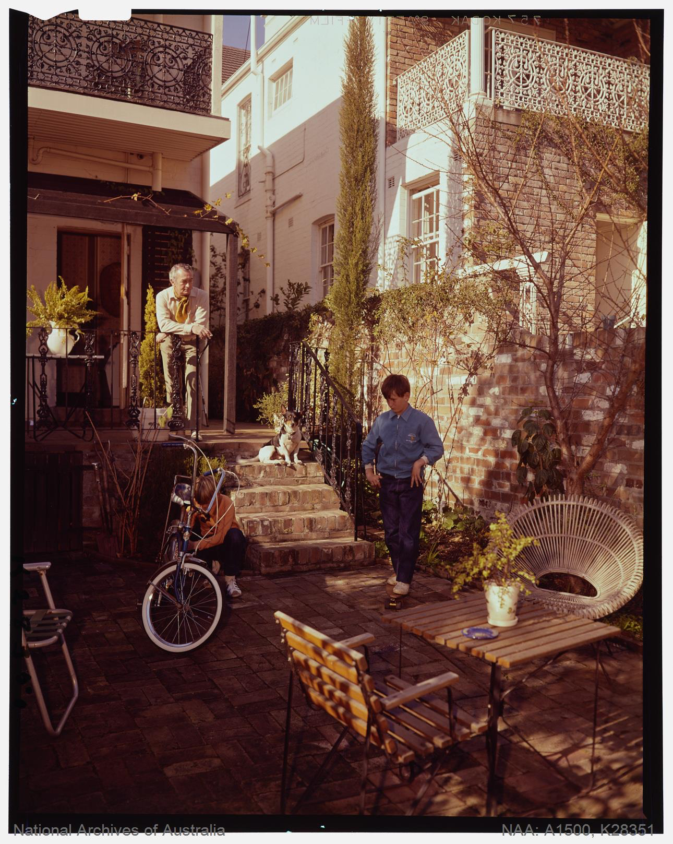
Housing - Homes and Homesteads - Garden Terrace House, Paddington, colour transparency, 1971, A1500, K28351, National Archives of Australia, Item ID 11781075, Sydney.

Published by the National Australian Archives, the Garden Terrace House in Paddington depicts a 1970s bohemian family, characterised through the dragster bicycle and eclectic wood furniture. Young professionals and their children typically resided in suburban residences accompanied by spacious, fenced front yards, Sydney’s inner-city neighbourhoods offered an alternative. In Paddington, terrace homes opened onto the streets, reserving no space for a traditional front yard. Rather, secluded rear gardens afforded its inhabitants an outdoor sanctuary in the heart of the city. Providing greenery and the sense of retreat from the urban landscape. The narrow rectangular footprint and sparse soil made sprawling plants impractical. Hence, the garden is composed of hardy, upright vegetation that climbs along the brick walls, maximizing vertical space. Ornamental ferns and decorative potted urns were commonly dotted, adding texture and aesthetic features. The garden embodies adaptable design principles suitable to dense urban life, while reflecting the lifestyle values of its time.

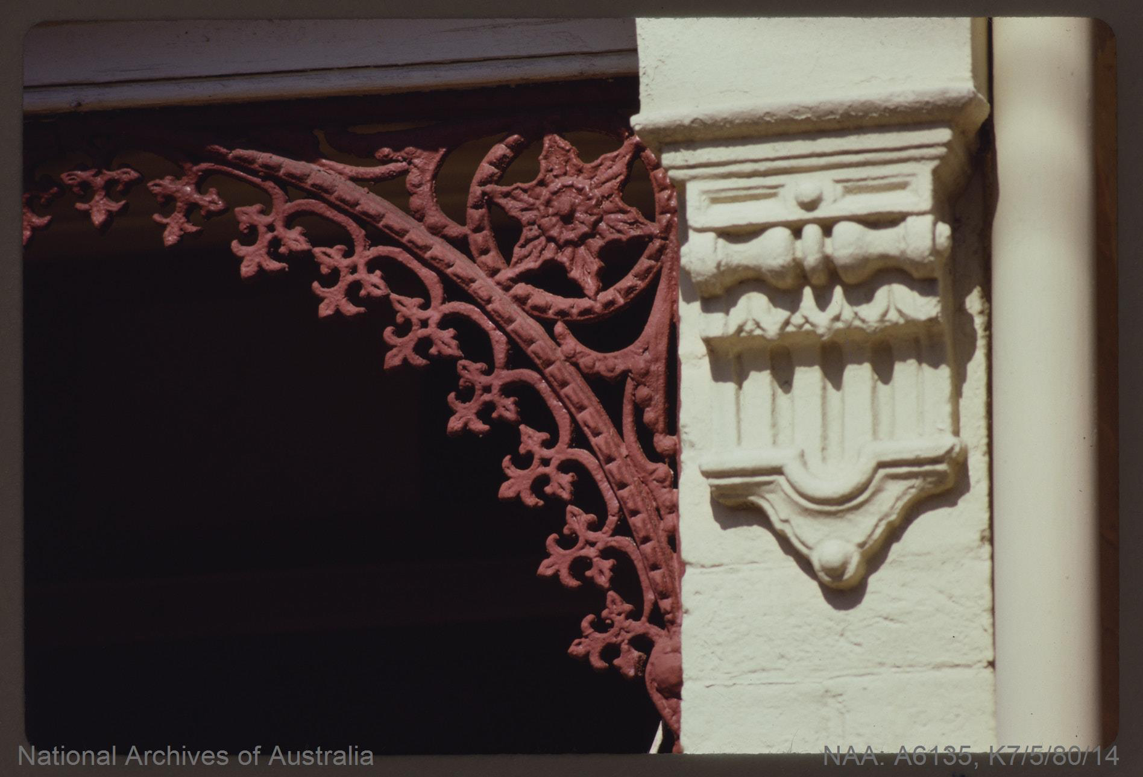
National Archives of Australia. Architecture – New South Wales – Decorated Column and Cast Iron Lace on Glebe Terrace House. 1980. Photograph. Series A6135, Control Symbol K7/5/80/14. Item ID 11653329. Sydney.

Published by the National Australian Archives, the photograph titled Decorated column and cast iron lace on Glebe Terrace House displays an iconic attribute of Australian terrace architecture emerging during the Victorian era, with motifs rooted in the Regency period, notably between 1830 to 1860. The earliest decorative ironwork was imported to Tasmania and New South Wales from Great Britain; however, by the 1840s domestic steel production began to boom across Australia, diminishing overseas supply. This development paved the way for regional variations in the cast iron ornamentation. Neighbourhoods like Glebe, commonly displayed this “filigree” on the verandah. The “iron lace” in New South Wales took on the moniker “Sydney lace.” Unlike other regions where such embellishment was far less common as they opted for simpler ornamentations. The dramatic stucco column and parapets were customary across Australia. Columns were adorned with intricate flourishes, showcasing the fusions of classical British design, baroque profiles, and traditional stonemasonry.

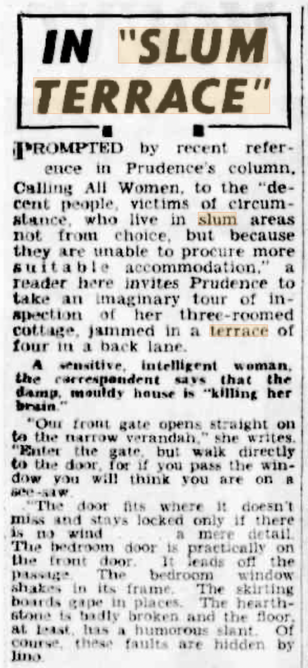

“In 'Slum Terrace.'” The Sun News-Pictorial (Melbourne, Vic.: 1922–1954; 1956), November 30, 1946. 16. Accessed April 8, 2025. http://nla.gov.au/nla.news-article279169274.

The Sun News Pictorial article titled In “Slum Terrace” offers a firsthand account on life in a deteriorating Australian terrace house in 1946. From the perspective of a described sensitive and intelligent woman, the piece counters the glamorized views of terrace housing through highlighting problems of structural neglect and overcrowding on small lots. She goes on to depict mouldy, damp, and gaping skirting boards, ill-fitted doors swung open by gusts of wind, causing rattling window frames. The illustration of the poor conditions reinforced their association with urban “slums.” Yet, as the 20th century progressed, the stigma had shifted. Urban renewal in communities such as Paddington, Carlton, and North Adelaide witnessed rehabilitation efforts, as labor and left-wing groups advocated for housing reform. These political and cultural initiatives brought about the reinvigoration and restored dignity to a once tattered dwelling, ending the terrace home correlation with the “slum.”

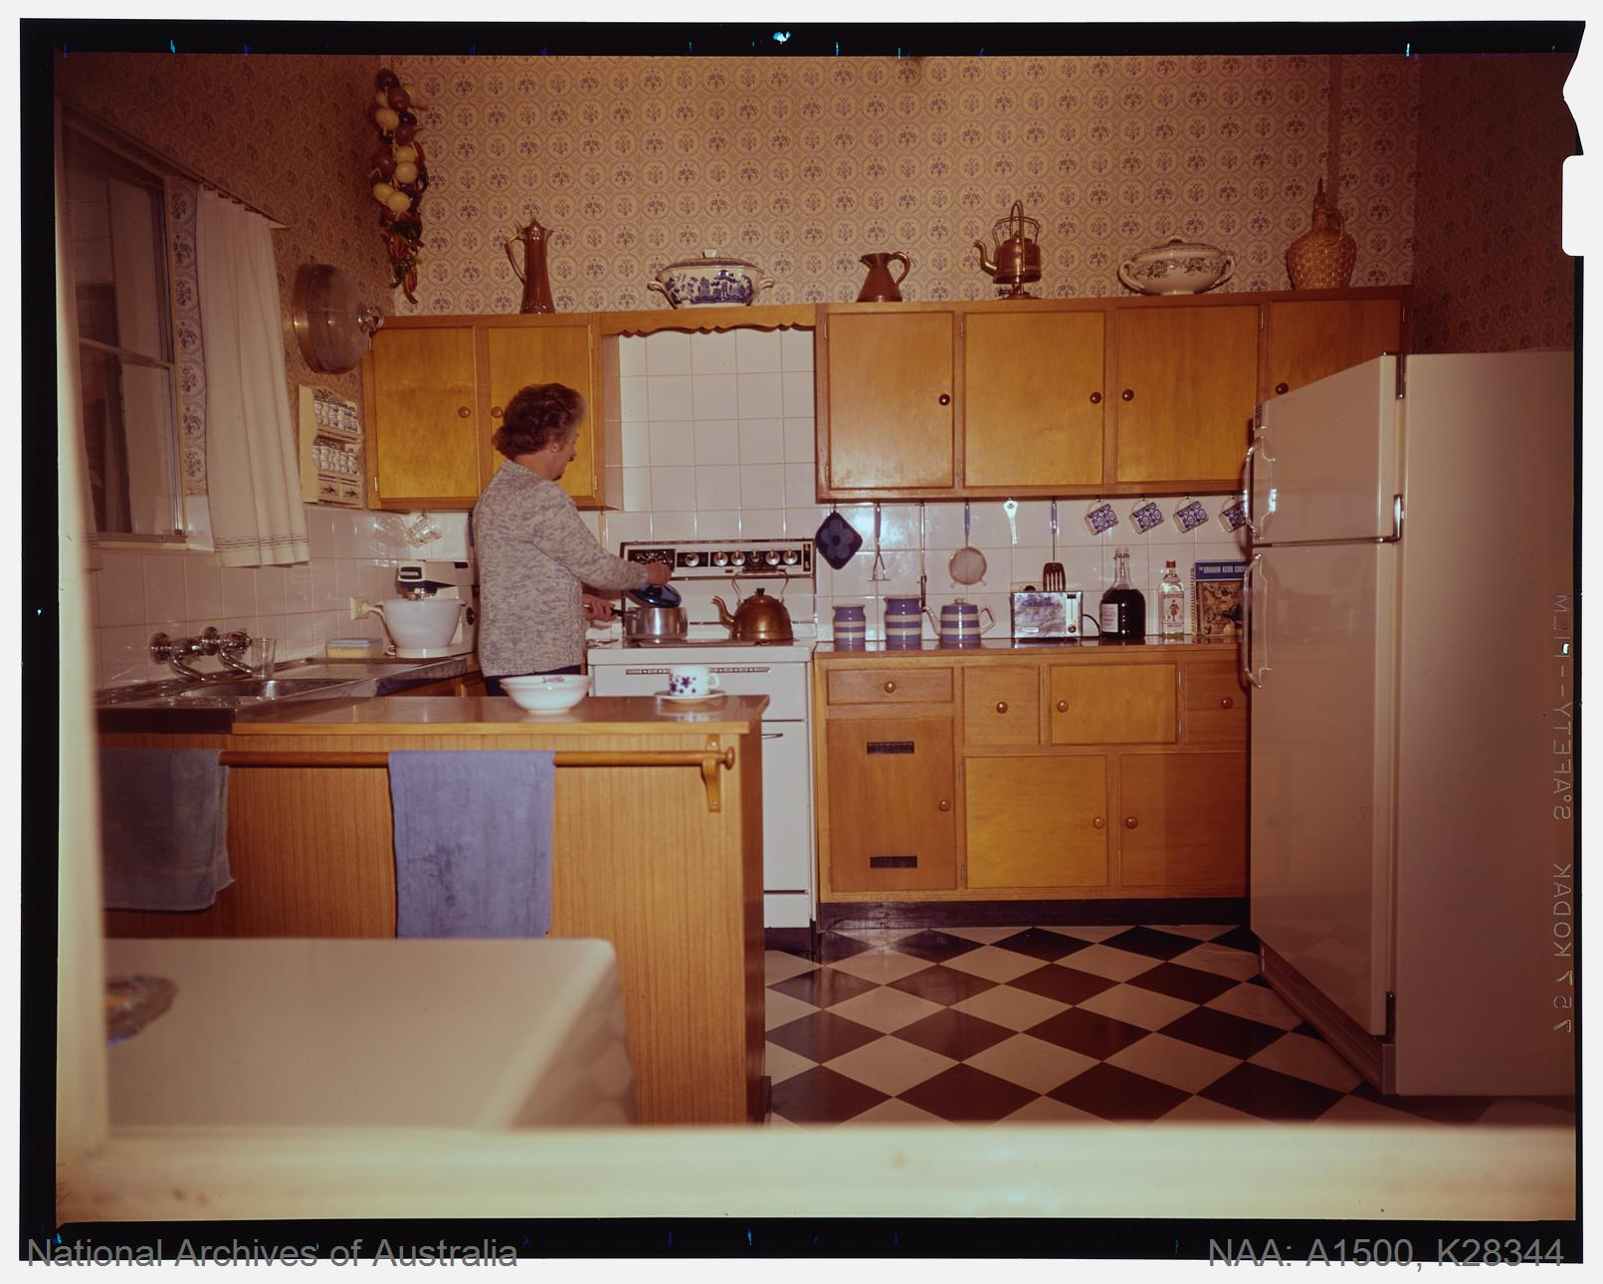

Housing – Homes and Homesteads – Garden, Terrace House, Paddington. Colour transparency. 1971. A1500, K28344. Item ID 11651656. National Archives of Australia, Sydney.

Published by the National Australian Archives, the second photograph under the Garden Terrace House, Paddington title reveals how public spaces in 1970s terraces had embraced fashionable renovations, whereas kitchens remained utilitarian. Subtle gestures towards aesthetics began to emerge in the kitchen. The kitchen adopts a U-shaped footprint, referred to as the “work triangle”; the stove on the right, working island on the left, and the sink is central, employed for efficiency. A white tile backsplash surrounds the stove and countertop, added for practicality in maintaining cleanliness and minimizing grime. Adorning elements such as floral wallpaper, timber cabinetry, linoleum checkered flooring, and ceramic ware signaled a trend towards personalization of the space. The absence of sweating indicates that the kitchen still remained distinct from the dining or social areas of the home, representing the reminiscence of utilitarian usage of the kitchen prior to the transition towards social and communal spaces.

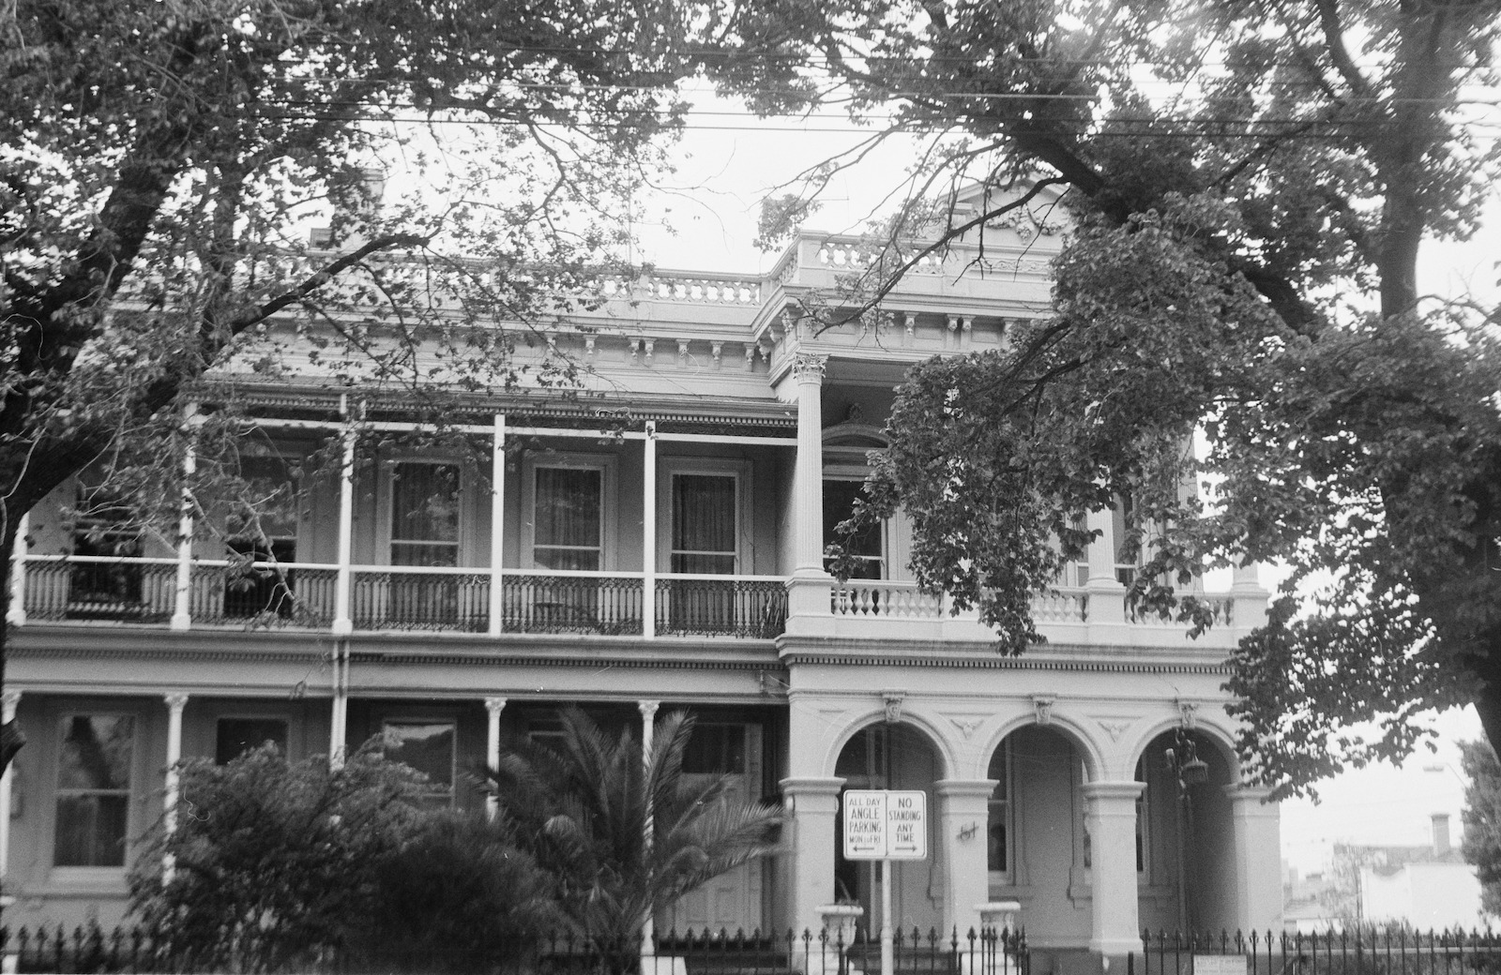

Committee for Urban Action (Melbourne, Vic.). St Vincent Place South, Albert Park, from Ferrars Street to Montague Street – South Side. 1974. State Library of Victoria. CUASM215/6-8 Image 16.

The Rochester Terrace, as seen in the St Vincent Place South, Albert Park, from Ferrars Street to Montague Street - south side stands as a defining example of Boom Style architecture, published by the State Library of Victoria. Constructed between 1868 and 1879, during Melbournes post-gold rush boom, the terrace reflects the city’s ambitious architecture and rising wealth. Inspired by Italianate villas, the Rochester Terrace was crafted with elegance in view, as signified by a lengthy facade, detailed verandas, and a deep, well landscaped front garden. Contrary to Sydney’s narrower, more utilitarian terrace houses, which balanced urban density and practical living, the Rochester Terrace projected comfort and social prestige. Its pavilioned composition, boasting flanking wings, presented a grand and orderly style to reflect elitist sensibilities. In a political reordering of the Emerald Hill neighbourhood away from a working class character, towards the high society of “Marvellous Melbourne.”
Situating the Terrace House
In Australian Architecture: A History, Davina Jackson discusses Sydney’s Early Terrace Houses, fixating on the Lyons Terrace, initially built with senior government officials in mind. Bearing sophisticated fences built of cast-iron, spanning verandahs, and two sprawling gardens, highlights the intersection of aesthetic refinement and class distinctions. Jackson’s analysis of contrasts between Sydney's quaint utilitarian terraces, such as in Paddington, and Melbournes marvelous boom-style terraces, like the Rochester Terrace, representing prosperity and social elitism. Jacksons mention of decorative elements, which draws similarities to the “Sydney lace” models a broader shift of adaptive expression. This theme of contextual adaptation runs perpetually since the Sydney terrace inception, as shown by the Paddington terraces, in which young homeowners customized their interiors, like kitchens, reflecting the changing lifestyles of its time period. Jacksons writing counters the idea that terraces were exclusively elitist dwellings. For example, in The Rocks, Irish immigrants adapted the terrace style home to fit their lifestyle and class situation. The Sun News Pictorial article on “slum terraces” exemplifies the decline of these buildings. Yet, urban renewal in the late 20th century represents the youthful reinvigoration of architectural and cultural sentiments into the homes. Jackson’s work contrasted with my findings demonstrating the changing dynamics that cultural, political, and economic factors have carried weight on the evolution of Terrace Houses in Australia.

References
The Australian Women's Weekly. 1972. “A Modern Terrace House.” February 2, 1972.
Heritage Council of Victoria, Rochester Terrace, last modified September 21, 2023, https://vhd.heritagecouncil.vic.gov.au/places/66660.
Heritage Council of Victoria, St Vincent Place Precinct Statement of Significance, accessed April 10, 2025, https://vhd.heritagecouncil.vic.gov.au/places/15/download-report.
Howells, Trevor, and Colleen Morris. 1999. Terrace Houses in Australia. N.p.: Lansdowne.
Jackson, Davina. 2022. Australian Architecture: A history. N.p.: Allen & Unwin.
Lloyd, Justine, and Ellie Vasta, eds. 2017. Reimagining Home in the 21st Century. N.p.: Edward Elgar Publishing.
Makio, Haruki, Daisuke Shinogi, Eiichi Sugimoto, Tetsu Tokuono, and Shigekazu Sugiyama. 2004. “History and Current Planning tasks of Terrace Houses in Melbourne.” Memoirs of the Faculty of Engineering Osaka City University 45 (December): 23-28. https://www.i-repository.net/contents/osakacu/kiyo/DB00011522.pdf.
Morris, Collen. 2008. “Lost Gardens of Sydney.” Australian Garden History 20, no. 1 (July/August/September): 4-9. https://www.jstor.org/stable/24918587.
Spearritt, Peter. 1973. “The Australian Slum Stigma.” The Australian and New Zealand Journal of Sociology 9 (2): 41-45. https://doi.org/10.1177/144078337300900209.

National Archives of Australia. Architecture – New South Wales – Decorated Column and Cast Iron Lace on Glebe Terrace House. 1980. Photograph. Series A6135, Control Symbol K7/5/80/14. Item ID 11653329. Sydney.

National Archives of Australia. Architecture – New South Wales – Decorated Column and Cast Iron Lace on Glebe Terrace House. 1980. Photograph. Series A6135, Control Symbol K7/5/80/14. Item ID 11653329. Sydney.

Committee for Urban Action (Melbourne, Vic.). St Vincent Place South, Albert Park, from Ferrars Street to Montague Street – South Side. 1974. State Library of Victoria. CUASM215/6-8 Image 16.

Housing – Homes and Homesteads – Garden, Terrace House, Paddington. Colour transparency. 1971. A1500, K28344. Item ID 11651656. National Archives of Australia, Sydney.

“In 'Slum Terrace.'” The Sun News-Pictorial (Melbourne, Vic.: 1922–1954; 1956), November 30, 1946. 16. Accessed April 8, 2025. http://nla.gov.au/nla.news-article279169274.

Artificial Intelligence Acknowledgement: AI was used to assist me in crafting my citations into Chicago Manual Style. It also aided me in ensuring my analyzation is polished and checks of my criteria. No research or information was provided by AI, solely aiding in sentence structure and articulation.

Colleen Morris, "Lost Gardens of Sydney," Australian Garden History 20, no. 1 (July/August/September 2008): 4-9, https://www.jstor.org/stable/24918587.
Trevor Howells and Colleen Morris, Terrace Houses in Australia (Sydney: Lansdowne, 1999).
Haruki Makio et al., "History and Current Planning Tasks of Terrace Houses in Melbourne," Memoirs of the Faculty of Engineering Osaka City University 45 (2004): 23–28.
Trevor Howells and Colleen Morris, Terrace Houses in Australia (Sydney: Lansdowne, 1999).
Peter Spearritt, “The Australian Slum Stigma,” The Australian and New Zealand Journal of Sociology 9, no. 2 (1973): 41–45, https://doi.org/10.1177/144078337300900209.
Lloyd, Justine, and Ellie Vasta, eds. 2017. Reimagining Home in the 21st Century. N.p.: Edward Elgar Publishing.
"A Modern Terrace House," The Australian Women's Weekly (February 2, 1972): 80, accessed April 9, 2025, http://nla.gov.au/nla.news-article46470335.
Heritage Council of Victoria, Rochester Terrace, last modified September 21, 2023, https://vhd.heritagecouncil.vic.gov.au/places/66660.
Heritage Council of Victoria, St Vincent Place Precinct Statement of Significance, accessed April 10, 2025, https://vhd.heritagecouncil.vic.gov.au/places/15/download-report.
Trevor Howells and Colleen Morris, Terrace Houses in Australia (Sydney: Lansdowne, 1999).
Davina Jackson, Australian Architecture: A History (N.p.: Allen & Unwin, 2022).

